Content Search 2.2A – The Classical Empires pt.1
As states and empires increased in numbers, size, and population, they frequently competed for resources and came into contact with one another. The number and size of key states and empires grew dramatically as rulers imposed political unity on areas where previously there had been competing states. Since there is a number of early empires the College Board requires of you to study, we are going to break this Key Concept into two parts: this first one will focus on the Persian Empires, The Hellenistic Empire, and the Mauryan/Gupta Empires.
- First, it is important to know the location and names of the following states and empires, so use this map and color/label the following areas. Put a and label their important trade cities listed below each
  - Persian Empire - green
  - Mauryan and Gupta Empires - pink
    - Patalitputra
  - Phoenicia and its colonies - purple
  - Greek city-states – blue
    - Athens
  - Hellenistic Empire (conquered the Persian Empire, then was dissolved) – just label beside Persian
    - Alexandria
    - Constantinople
    - Persepolis
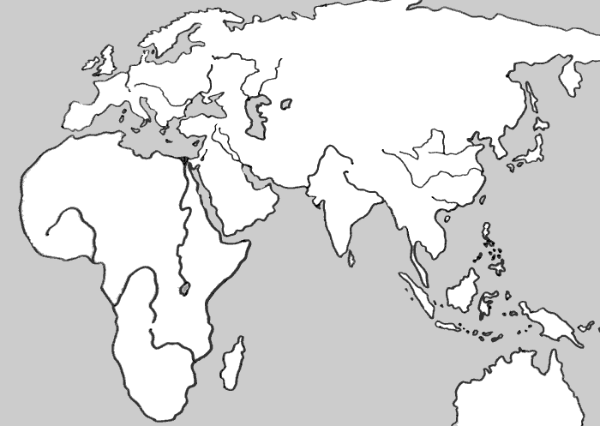

- Since it was difficult to organize and control their subjects over large areas, imperial rulers during this era used a variety of techniques such as centralizing their government, using decentralized bureaucracies, or other elaborate legal systems.
  - Describe how the Mauryan Empire used centralized government to control its people.
    - Website: AP History 101 - Mauryan dynasty - http://apworldhistory101.com/history-of-india/mauryan/
    - Video: Mauryan government - https://www.youtube.com/watch?v=l2XcZL-6iKI
    - Amsco: p. 95-97

  - Explain how the Gupta Empire used a more decentralized form of management.
    - Website: Gale Encyclopedia – Gupta Government link.galegroup.com/apps/doc/CX3048600033/WHIC?u=nysl_ro_hilton&xid=1f29d6dc
    - Video lecture: Gupta Dynasty - https://www.youtube.com/watch?v=EZWy7IFBCEQ

- Imperial governments promoted trade and projected military power over larger areas using a variety of techniques, including issuing currencies; developing supply lines; building defensive walls and roads, and including new groups of military officers and soldiers from conquered areas.
  - Note how the Gupta dynasty used common currency to connect their land holdings
    - Article: Coins of the Gupta Dynasty - http://www.indianetzone.com/2/coins_gupta_dynasty.htm

  - Record the military tactics of Alexander the Great and how he provided for his armies
    - Article: The Supply Chains of Alexander the Great - http://blog.scmglobe.com/?p=385
    - Video: Alexander the Great logistics - https://www.youtube.com/watch?v=rW-MAK7bfLA

- Imperial cities served as centers of trade, religious rituals, and political administration for the state or empire.
  - Describe how the city of Persepolis showed the power of the Persian Empire
    - Website: Persepolis, The Audience Hall of Darius and Xerses - https://www.khanacademy.org/humanities/ancient-art-civilizations/ancient-near-east1/persian/a/persepolis
    - Video: Ancient Persepolis - https://www.youtube.com/watch?v=fVaO5X77apA

- The social structures of empires displayed hierarchies that included cultivators, laborers, slaves, artisans, merchants, elites, or caste groups.
  - Draw and illustrate the Indian Caste system
    - Article: History of the Caste System - https://www.thoughtco.com/history-of-indias-caste-system-195496
    - Video Lecture: The Indian Caste System - https://www.youtube.com/watch?v=ERxLSURibeQ
    - AMSCO: p. 92-93

- Imperial societies relied on a range of methods to maintain the production of food and provide rewards for the loyalty of the elites.
  - Even though they are usually known for their contributions to democracy and freedom, note how the early Greeks used slavery in their society.
    - Article: 10 facts on Slavery in Ancient Greece - http://listverse.com/2016/09/29/10-fascinating-facts-about-slavery-in-ancient-greece/
    - Video: Ancient Greek Slavery - https://www.youtube.com/watch?v=CkVBOqEGBVY

- All of the classical empires created political, cultural, and administrative difficulties that they could not manage, which eventually led to their decline, collapse, and transformation into successor empires or states.
  - Research the underlying reasons as to why the Gupta Empire eventually declined
    - PDF reading: Gupta Empire’s Decline (pg.6) - https://static1.squarespace.com/static/53b17013e4b0f83f2d8a8a4a/t/53c51d2ae4b0d5fd0ebe7b9b/1405426986221/FALL+OF+THE+CLASSICAL+EMPIRES+FREEMANPEDIA+.pdf
    - Video: Gupta - Draw My Decline - https://www.youtube.com/watch?v=ukephXMBkAc
    - AMSCO: p. 99-100

