Content Search 2.2B – The Classical Empires pt.2
As states and empires increased in numbers, size, and population, they frequently competed for resources and came into contact with one another. The number and size of key states and empires grew dramatically as rulers imposed political unity on areas where previously there had been competing states. Since there is a number of early empires the College Board requires of you to study, we are going to break this Key Concept into two parts: this is the 2nd part and will focus on the Romans and Chinese (Qin and Han dynasties), but we must also note that ancient American civilizations are also in existence during this time period.
- First, it is important to know the location and names of the following states and empires, so use this map and color/label the following areas. Put a star and label their important trade cities listed below each
  - Roman Empire - Red
    - Rome
    - Carthage
    - Alexandria
    - Constantinople
    - Athens
  - Qin and Han China – Yellow (color light yellow for area controlled by Qin and darker yellow to show where Han dynasty expanded to)
    - Chang’an
  - The Mayans - orange
  - The Moche - brown
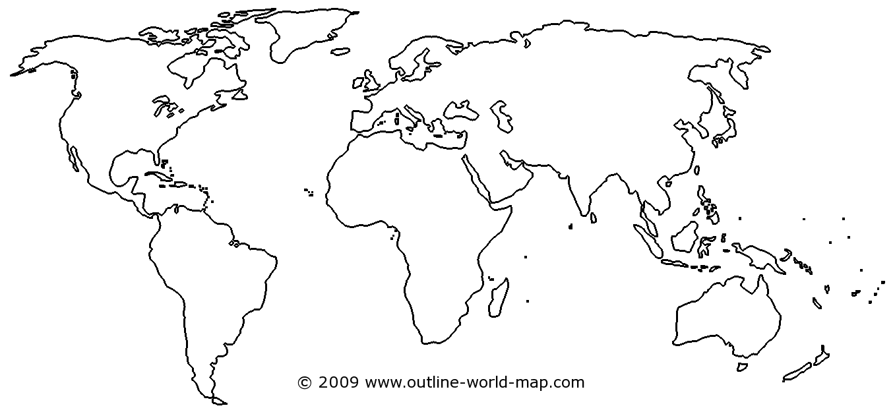

- Since it was difficult to organize and control their subjects over large areas, imperial rulers during this era used a variety of techniques such as centralizing their government, using decentralized bureaucracies, or other elaborate legal systems.
  - Explain the methods used by the Qin AND Han dynasties in China to better control its people and strengthen their government after the warring states period.
    - Website: AP Worldipedia (scroll down to “Centralized Governments: Case Studies” – East Asia) http://apworldipedia.com/index.php?title=Key_Concept_2.2_The_Development_of_States_and_Empires
    - Prezi: Qin and Han comparison - https://prezi.com/_dqdfjnk1-z8/qin-dynasty-vs-han-dynasty/
    - AMSCO: p. 102-105

  - Reference the variety of ways in which the Roman government managed their expanding populations
    - Website: AP Worldipedia (scroll down to “Centralized Governments: Case Studies” – The Roman Empire) http://apworldipedia.com/index.php?title=Key_Concept_2.2_The_Development_of_States_and_Empires
    - Video Lecture: Roman Law and Government - https://www.youtube.com/watch?v=fIcJZu7EF24

- Imperial governments promoted trade and projected military power over larger areas using a variety of techniques, including issuing currencies; developing supply lines; building defensive walls and roads, and including new groups of military officers and soldiers from conquered areas.
  - Describe the extent of the Roman roads that were used to connect the vast empire
    - Article: The Roman Roads https://www.ancient.eu/article/758/roman-roads/
    - Video: History Channel of The Roman Roads - https://www.youtube.com/watch?v=XRYHsiCvmhc (Watch from 3:15-7:28)

  - Note why the Qin and Han used defensive walls to protect their people
    - Article: The History of the Great Wall - https://www.travelchinaguide.com/china_great_wall/history/ (only research Qin and Han)
    - Video: How and Why the Great Wall was Built - https://www.youtube.com/watch?v=m68zyXyeYG0

- Imperial societies relied on a range of methods to maintain the production of food and provide rewards for the loyalty of the elites.
  - Some amount slavery was practiced in all classical civilization, but slaves may have comprised as much as one third of the Roman Empire’s population. Expand upon the history of slavery in the Roman Empire.
    - AMSCO: pg. 76-79
    - Article: Slavery in the Roman World - https://www.ancient.eu/article/629/slavery-in-the-roman-world/
    - Video: Ancient Roman and Chinese Slavery - https://www.youtube.com/watch?v=W94bFV3NukM

  - The Qin and Han dynasties used corvee’ labor (or forced labor for limited time) in order to fulfill the massive construction projects demanded by the Emperor. Take notes on one of the following accomplishments of their enormous workforce.
    - Video: The Terra-Cotta Warriors - https://www.youtube.com/watch?v=RsUE-ZtcUFg
    - Video and Article: The Great Wall of China (focus on the labor and stop before the Ming Dynasty) http://www.history.com/topics/great-wall-of-china

- All of the classical empires created political, cultural, and administrative difficulties that they could not manage, which eventually led to their decline, collapse, and transformation into successor empires or states.
  - Research the underlying reasons as to why the Han Dynasty came to a close
    - AMSCO: pg. 105
    - Article: How the Han Dynasty Fell - https://www.thoughtco.com/why-did-han-china-collapse-195115
    - Powerpoint video lecture: The Decline of Han China https://www.youtube.com/watch?v=mSdLo_7s8AY

  - Explain the main causes of the fall of the Roman Empire
    - AMSCO: pg. 83-84
    - Crash Course: The Fall of Rome - https://www.youtube.com/watch?v=3PszVWZNWVA
    - Article: 8 Reasons Why Rome Fell - http://www.history.com/news/history-lists/8-reasons-why-rome-fell
Key Concept 2.2 Vocab
Historical Terms | Non-Historical Terms
- Persian Empire  - Phoenicians  - Athens  - Sparta  - Hellenistic Empire  - Alexander the Great  - Persepolis  - Ashoka  - Gupta Empire  - Mauryan Empire  - Roman Empire  - Roman Empire  - Qin Dynasty  - Han Dynasty  - Great Wall of China  - Terra Cotta Soldiers  - Corvee Labor | - Currency  - Bureaucracy  - Imperial  - Decentralized  - Empire  - Dynasty  - Political Unity  - Warring States

