Life in the Trenches
The first major trench lines were completed in late November 1914. At their peak, the trenches built by both sides extended nearly 400 miles from Nieuport, on the Belgian coast, to the Swiss border. Among the Allies, the Belgians occupied 40 miles, the British occupied 90 miles and the French occupied the rest. Experts calculate that along the western front, the Allies and Central Powers dug nearly 6,2500 miles of trenches by the end of 1914.

Daily Death in the Trenches
Death was a constant companion to those serving in the line, even when no raid or attack was launched or defended against. In busy sectors the constant shellfire directed by the enemy brought random death, whether their victims were lounging in a trench or lying in a dugout (many men were buried as a consequence of such large shell-bursts).
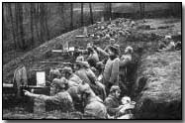
Similarly, novices were cautioned against their natural inclination to peer over the parapet of the trench into No Man's Land. Many men died on their first day in the trenches as a consequence of a precisely aimed sniper's bullet. It has been estimated that up to one third of Allied casualties on the Western Front were actually sustained in the trenches. Aside from enemy injuries, disease wrought a heavy toll.

Rat Infestation
Rats in their millions infested trenches. There were two main types, the brown and the black rat. Both were despised but the brown rat was especially feared. Gorging themselves on human remains (grotesquely disfiguring them by eating their eyes and liver) they could grow to the size of a cat.
Men, exasperated and afraid of these rats (which would even scamper across their faces in the dark), would attempt to rid the trenches of them by various methods: gunfire, with the bayonet, and even by clubbing them to death.
It was futile however: a single rat couple could produce up to 900 offspring in a year, spreading infection and contaminating food. The rat problem remained for the duration of the war (although many veteran soldiers swore that rats sensed impending heavy enemy shellfire and consequently disappeared from view).
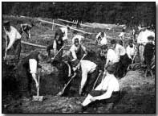
Disease
Rats were by no means the only source of infection and nuisance. Lice were a never-ending problem, breeding in the seams of filthy clothing and causing men to itch unceasingly.
Even when clothing was periodically washed and deloused, lice eggs invariably remained hidden in the seams; within a few hours of the clothes being re-worn the body heat generated would cause the eggs to hatch.
Lice caused Trench Fever, a particularly painful disease that began suddenly with severe pain followed by high fever. Recovery - away from the trenches - took up to twelve weeks. Lice were not actually identified as the culprit of Trench Fever until 1918.
Many men chose to shave their heads entirely to avoid another prevalent scourge: nits.
Trench Foot was another medical condition peculiar to trench life. It was a fungal infection of the feet caused by cold, wet and unsanitary trench conditions. It could turn gangrenous and result in amputation. Trench Foot was more of a problem at the start of trench warfare; as conditions improved in 1915 it rapidly faded, although a trickle of cases continued throughout the war.

Propaganda
During World War One, propaganda was employed on a global scale. Unlike previous wars, this was the first total war in which whole nations and not just professional armies were locked in mortal combat. This and subsequent modern wars required propaganda to mobilize hatred against the enemy; to convince the population of the justness of the cause; to enlist the active support and cooperation of neutral countries; and to strengthen the support of allies.

Total War helped by Propaganda
For the first time, entire populations – women and children included – would be required to maintain the rate of production needed for food, clothes, and munitions to keep armies fighting. For many countries, advances in political representation meant that a greater proportion of the population (although still almost exclusively men) now had an influence on the direction of state policy, and could remove governments perceived as not acting in their interests.
The global nature of the war meant that the European powers needed to convince those around the world to support them. This included the subjects of colonies in Asia, Africa and the Caribbean, as well as neutral countries, to appeal for resources or financial support to continue the fight. All these factors came together to convince leaders of states of the importance of propaganda, and of coordinating propaganda efforts.

Propaganda posters
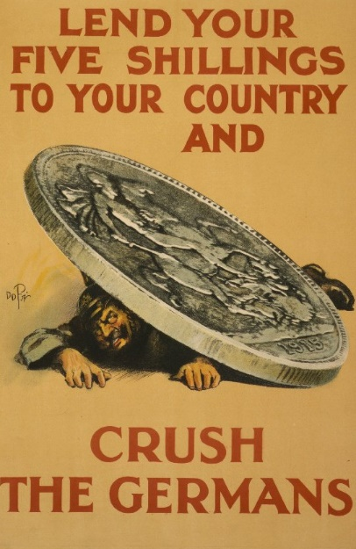
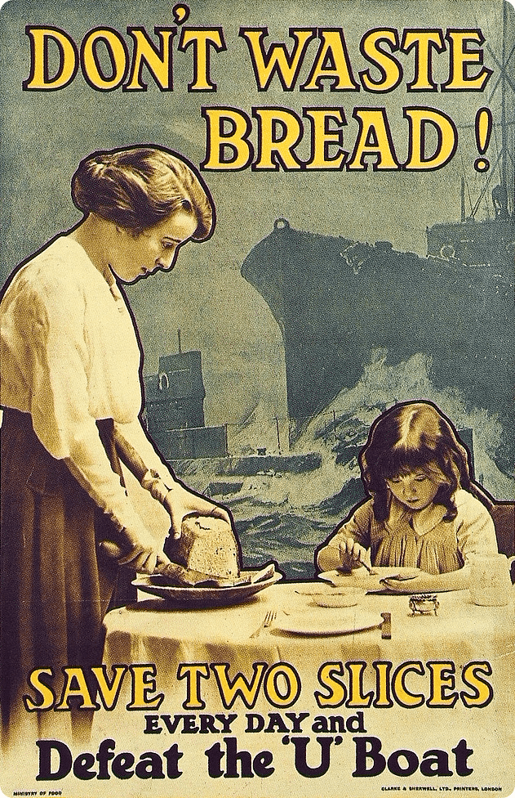
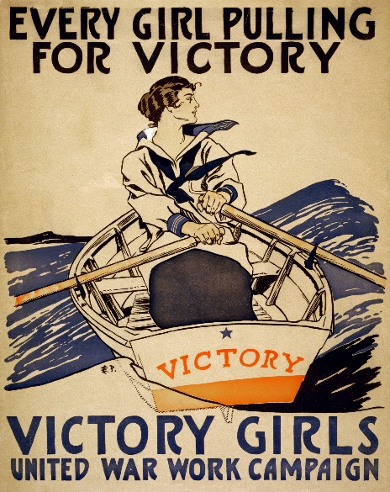
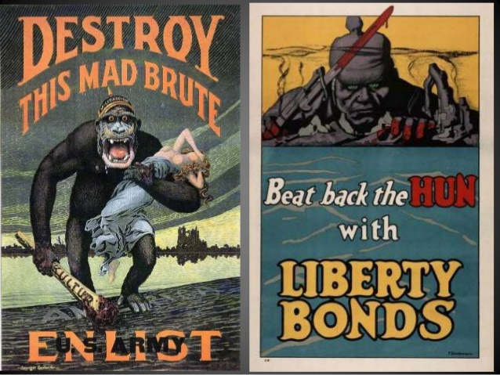
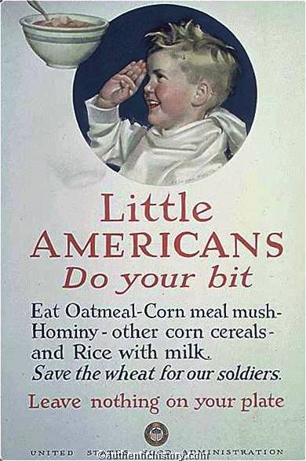
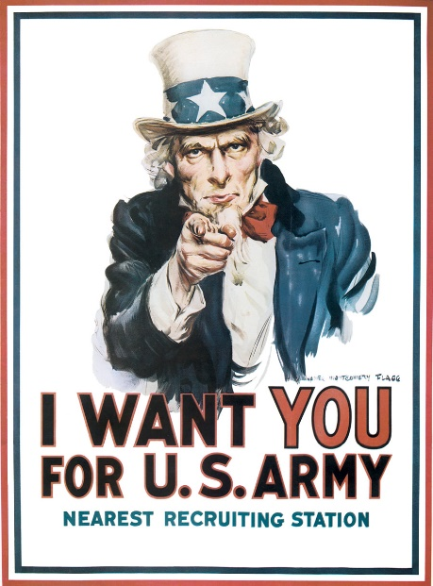

“Total War” in World War I
World War I was a total war, involving the governments, economies and populations of participating nations to an extent never seen before in history. This was distinct from the way ‘smaller’ wars had been fought, like the Crimean War (1853-56) and late-19th century colonial wars. In ‘total war’ – a term not coined until the 1930s, by German general Paul von Ludendorff – the entire nation was called into service, rather than just its military. Governments played an active and interventionist role, passing laws that would be intolerable during peacetime. Ministers and departments took control of economic production, nationalizing factories, determining production targets, allocating manpower and resources. Conscription was introduced to bolster military forces and resources like ships, trains or vehicles were commandeered for military purposes. Wartime governments also acted to protect national security, by implementing press censorship, curfews and strict punishments for breaches and violations. They also made extensive use of propaganda, both to raise public morale and to raise money through war bonds.

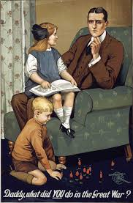
Britain
Britain initiated total war from the outset. A week after the declaration of war, the parliament at Westminster passed the Defence of the Realm Act. This legislation empowered the government to secure the nation from internal threat or invasion, by handing it wide-ranging powers, including censorship, the authority to imprison without trial and the power to court martial and execute civilians. Control of the press and communication media was particularly stringent. London appointed ‘official’ military journalists and set up the War Office Press Bureau, which processed stories and distributed them to newspapers (very few civilian reporters were ever let near the front lines). Government agencies and the military were authorized to prevent the publication of offensive or dangerous material in newspapers and books; to open and censor civilian mail; and to tap into telegraph and telephone communications. As the war progressed, new restrictions were added to the legislation. Daylight saving was introduced to provide more working hours in the day. Alcohol consumption was restricted, opening hours of pubs were cut back and beer was watered down to reduce its strength. It became illegal to light bonfires or fly kites, both of which might attract enemy airships.

Germany
In Germany, Walter Rathenau was put in charge of the Kriegsrohstoffabteilung, or War Raw Materials Department. As Germany started to suffer shortages caused by an Allied naval blockade, Rathenau’s skillful coordination of available raw materials and synthetic substitutes allowed industrial production to continue. But after two years these resources were severely depleted, and by 1916 production levels were falling. Military commanders Paul von Hindenburg and Erich Ludendorff implemented a series of reforms to double production of military needs. The Oberster Kriegsamt, or Supreme War Office, was formed to control and coordinate all aspects of wartime production, labor, industry and transport. The Auxiliary Service Law, passed in late 1916, empowered the government to employ and relocate any adult males it needed to meet its labor needs. More than two million men were forced out of the agricultural sector to work in weapons and munitions production. This had the desired military outcome, however the reallocation of labor saw production of both food and consumer goods plummet. These shortages, exacerbated by the ongoing Allied blockade, led to critical food shortages by the winter of 1916.
France
The French economy also mobilized to meet the nation’s war needs, though this was achieved with less government intervention than in Germany and Britain. France’s war production was left largely to groups of privately-owned companies, each responsible for a particular military necessity (there were fifteen groups responsible for producing shells, for example, and three groups for producing rifles). These consortiums received government orders and targets, then worked collaboratively to fill them. This system worked in principle, though France as a whole lacked the production capacity of Germany; it produced only one-sixth the amount of coal as Germany, and it was also hamstrung by the loss of some key industrial areas in 1914. Nevertheless the French achieved some spectacular increases in armaments production. By 1918 French producers were making 1,000 artillery guns, 261,000 shells and six million bullets per month. At the outbreak of war there were 162 aircraft in France; by 1918 there were more than 11,800. These striking increases made France the largest Allied producer of weapons and munitions, exceeding even the United States. Socially, the demands of the war economy took their toll on France’s workers, who suffered from stagnant wages and rising prices.

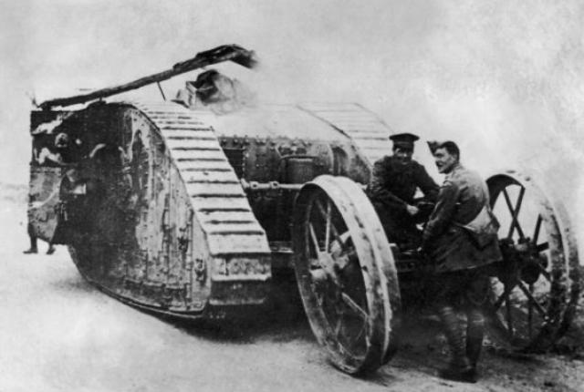
Military Technology Part I
Tanks
In 1914, the “war of movement” expected by most European generals settled down into an unexpected, and seemingly unwinnable, war of trenches. With machine guns reinforcing massed rifle fire from the defending trenches, attackers were mowed down by the thousands before they could even get to the other side of “no-man’s-land.”

A solution presented itself, however, in the form of the automobile, which took the world by storm after 1900. Powered by a small internal combustion engine burning diesel or gas, a heavily-armored vehicle could advance even in the face of overwhelming small arms fire. Add some serious guns and replace the wheels with armored treads to handle rough terrain, and the tank was born.
The first tank, the British Mark I, was designed in 1915 and first saw combat at the Somme in September 1916. The French soon followed suit with the Renault FT, which established the classic tank look (turret on top). Despite their later prowess in tank combat in WWII, the Germans never got around to large-scale tank production in WWI, although they did produce 21 tanks in the unwieldy A7V model.

Flamethrowers
Although the Byzantines and Chinese used weapons that hurled flaming material in the medieval period, the first design for a modern flamethrower was submitted to the German Army by Richard Fiedler in 1901, and the devices were tested by the Germans with an experimental detachment in 1911. Their true potential was only realized during trench warfare, however. After a massed assault on enemy lines, it wasn’t uncommon for enemy soldiers to hole up in bunkers and dugouts hollowed into the side of the trenches. Unlike grenades, flamethrowers could “neutralize” (i.e. burn alive) enemy soldiers in these confined spaces without inflicting structural damage (the bunkers might come in handy for the new residents). The flamethrower was first used by German troops near Verdun in February 1915.

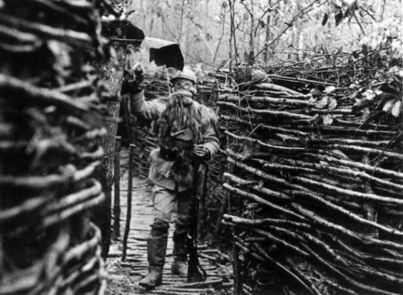
Poison Gas
Poison gas was used by both sides with devastating results (well, sometimes) during the Great War. The Germans pioneered the large-scale use of chemical weapons with a gas attack on Russian positions on January 31, 1915, during the Battle of Bolimov, but low temperatures froze the poison (xylyl bromide) in the shells. The first successful use of chemical weapons occurred on April 22, 1915, near Ypres, when the Germans sprayed chlorine gas from large cylinders towards trenches held by French colonial troops. The defenders fled, but typically for the First World War, this didn’t yield a decisive result: the Germans were slow to follow up with infantry attacks, the gas dissipated, and the Allied defenses were restored. Before long, of course, the Allies were using poison gas too, and over the course of the war both sides resorted to increasingly insidious compounds to beat gas masks, another new invention; thus the overall result was a huge increase in misery for not much change in the strategic situation (a recurring theme of the war).

Interrupreter Gear
Airplanes had been around for just a decade when WWI started, and while they had obvious potential for combat applications as an aerial platform for bombs and machine guns, it wasn’t quite clear how the latter would work, since the propeller blades got in the way. In the first attempt, the U.S. Army basically tied the gun to the plane (pointing towards the ground) with a leather strap, and it was operated by a gunner who sat beside the pilot. This was not ideal for aerial combat and inconvenient because it required two airmen to operate. Another solution was mounting the gun well above the pilot, so the bullets cleared the propeller blades, but this made it hard to aim. After the Swiss engineer Franz Schneider patented his idea for an interrupter gear in 1913, a finished version was presented by Dutch designer Anthony Fokker, whose “synchronizer,” centered on a cam attached to the propeller shaft, allowed a machine gun to fire between the blades of a spinning propeller. The Germans adopted Fokker’s invention in May 1915, and the Allies soon produced their own versions. Schneider later sued Fokker for patent infringement.
Military Technology Part II
Air Traffic Control
In the first days of flight, once a plane left the ground the pilot was pretty much isolated from the terrestrial world, unable to receive any information aside from obvious signals using flags or lamps. This changed thanks to the efforts of the U.S. Army, which installed the first operational two-way radios in planes during the Great War (but prior to U.S. involvement). Development began in 1915 at San Diego, and by 1916 technicians could send a radio telegraph over a distance of 140 miles; radio telegraph messages were also exchanged between planes in flight. Finally, in 1917, for the first time a human voice was transmitted by radio from a plane in flight to an operator on the ground.

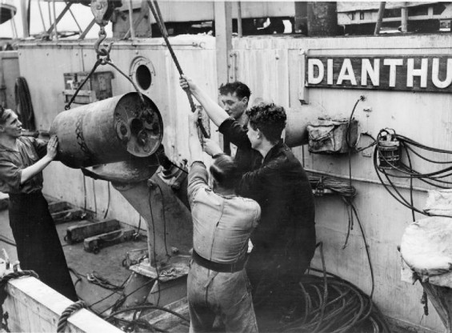
Depth Charge
The German U-boat campaign against Allied shipping sank millions of tons of cargo and killed tens of thousands of sailors and civilians, forcing the Allies to figure out a way to combat the submarine menace. The solution was the depth charge, basically an underwater bomb that could be lobbed from the deck of a ship using a catapult or chute. Depth charges were set to go off at a certain depth by a hydrostatic pistol that measured water pressure, insuring the depth charge wouldn’t damage surface vessels, including the launch ship. After the idea was sketched out in 1913, the first practical depth charge, the Type D, was produced by the Royal Navy’s Torpedo and Mine School in January 1916. The first German U-boat sunk by depth charge was the U-68, destroyed on March 22, 1916.

Hydro Phones
Of course it was a big help if you could actually locate the U-boat using sound waves, which required a microphone that could work underwater, or hydrophone. The first hydrophone was invented by 1914 by Reginald Fessenden, a Canadian inventor who actually started working on the idea as a way to locate icebergs following the Titanic disaster; however, it was of limited use because it couldn’t tell the direction of an underwater object, only the distance. The hydrophone was further improved by the Frenchman Paul Langevin and Russian Constantin Chilowsky, who invented an ultrasound transducer relying on piezoelectricity, or the electric charge held in certain minerals: a thin layer of quartz held between two metal plates responded to tiny changes in water pressure resulting from sound waves, allowing the user to determine both the distance and direction of an underwater object. The hydrophone claimed its first U-boat victim in April 1916. A later version perfected by the Americans could detect U-boats up to 25 miles away.
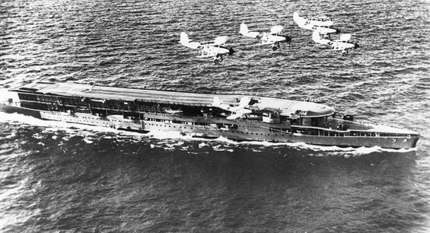
Air Craft Carriers
The first time an airplane was launched from a moving ship was in May 1912, when commander Charles Rumney Samson piloted a Short S.27 pontoon biplane from a ramp on the deck of the HMS Hibernia in Weymouth Bay. However, the Hibernia wasn’t a true aircraft carrier, since planes couldn’t land on its deck; they had to set down on the water and then be retrieved, slowing the whole process considerably. The first real aircraft carrier was the HMS Furious, which began life as a 786-foot-long battle cruiser equipped with two massive 18-inch guns—until British naval designers figured out that these guns were so large they might shake the ship to pieces. Looking for another use for the vessel, they built a long platform capable of both launching and landing airplanes. To make more room for takeoffs and landings, the airplanes were stored in hangars under the runway, as they still are in modern aircraft carriers. Squadron Commander Edward Dunning became the first person to land a plane on a moving ship when he landed a Sopwith Pup on the Furious on August 2, 1917.

