Document 1

Source: Tacitus, Roman historian, from Agricola, biography of the governor of Britain, AD 78-84

“People that are scattered and uncivilized are quick to fight. To make them ready to accept peace and leisure he had to prove how pleasant these are, so he encouraged individuals and communities alike, and gave them official assistance to build temples, town centers, and houses, praising all who cooperated, and rebuking anyone who was reluctant. He went on to make sure sons of the chieftains had a proper education. Consequently, men who had a short time before refused to learn Latin were now keen to speak it fluently. In their simplicity they called it civilization – it was in fact merely one method of keeping them quiet.”

Document 2

Source: Aelius Aristides, Greco-Roman writer, his public writings, 150 CE

“Most wonderful of all is your noble idea of citizenship. For you have divided all the people of the empire into two groups. The more cultured, better born, and more influential everywhere - you have declared Roman citizens. Everything lies open to everybody, and no one who is worthy to be trusted with public office is considered a foreigner. There are many people in each city who are citizens. You have no need to keep troops in these cities; the most influential men everywhere keep watch over their own native places for you. You have a double hold on these cities – from Rome and through the Roman citizens in each.”

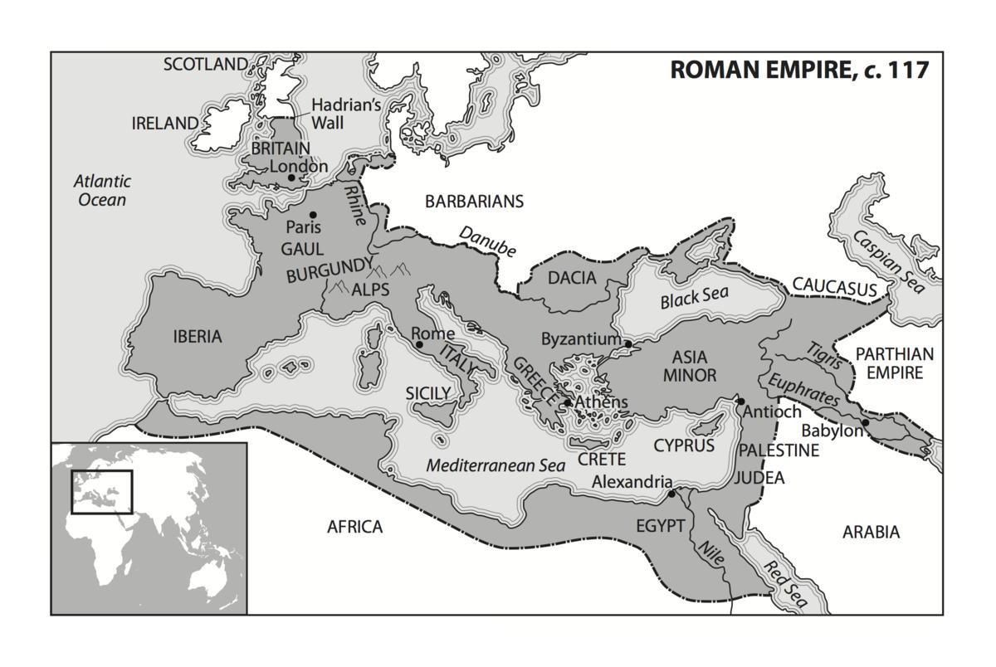
Document 3

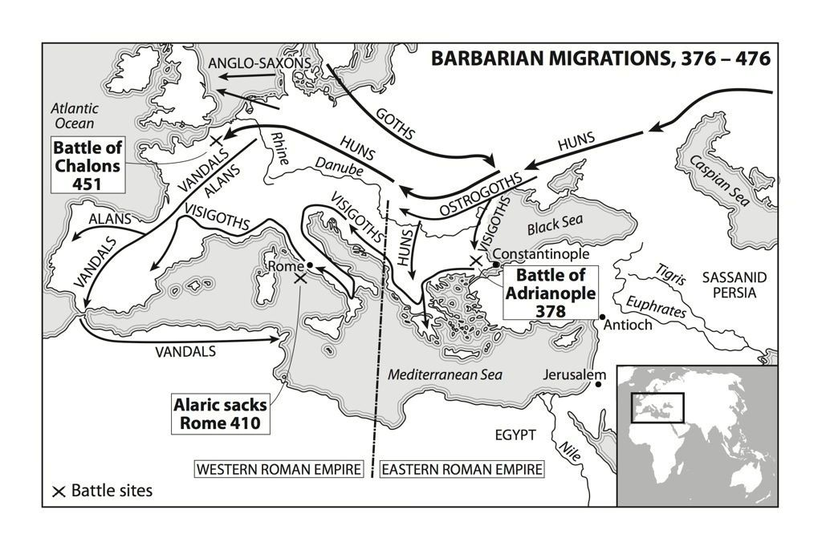
Document 4
Source: Michael Grant, The Fall of the Roman Empire: A Reappraisal, Crown Publishing, 1982

There can be little doubt that the weakness of the late Roman army were largely due to the eventual failure … to enforce regular conscription [draft of soldiers] … The exempted categories were … numerous. Hosts of senators, bureaucrats, and clergymen were entitled to avoid the draft; and among other groups who escaped were cooks, bakers, and slaves.
This excerpt is from Romans Without Laurels by Indro Montanelli and blames the fall on “internal decay” specifically that of the military.

Rome, like all great empires, was not overthrown by external enemies but undermined by internal decay … The military crisis was the result of … proud old aristocracy’s … shortage of children. [Consequently] foreigners poured into this …void [lack of soldiers]. The Roman army [was] composed entirely of Germans.

Document 5

Document 6
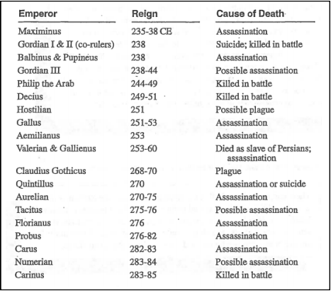
Document 7
Source: Peter Stearns, Michael Adas, Stuwart Schwartz, Marc Lason Gilbert, World Civilizations: The Global Experience, Pearson Education, 2000.

More important in initiating the process of decline was a series of plagues that swept over the empire… which brought diseases [from] southern Asia to new areas like the Mediterranean, where no resistance had been established even to contagions such as the measles. The resulting diseases decimated the population. The population of Rome decreased from a million people to 250,000. Economic life worsened in consequence. Recruitment of troops became more difficult, so the empire was increasingly reduced to hiring Germanic soldiers to guard its frontiers. The need to pay troops added to the demands on the state’s budget, just as declining production cut into tax revenues.

Document 8

Name:____________________

Fall of Rome DBQ

Directions: next to each document #, name the document. Then answer the questions that go with each document.

Document 1:
What does the author suggest about uncivilized people?

How does the author plan on controlling newly conquered peoples?

Document 2:
What are the two groups of people within the Roman Empire according to the author?

How does the author plan to keep the foreign cities under control?

Document 3:
How large is the Roman Empire? (what nations are under its control)

What are some problems you may encounter if you want control this much space?

Document 4:
What does the author suggest was a big problem in the Roman Empire?

Document 5:
What is being shown in this map?

Define barbarian?

Document 6:
What military problem is being explained in this document?

Document 7:
How many Emperors did Rome have between 235-285 C.E.?

How many were assassinated?

Document 8:
Define plague.

How did the Bubonic Plague effect the Roman Empire?

Short Answer Response: Must be 4-8 complete sentences.
Create a plan to help stop Rome from crumbling in at least 2 areas mentioned in the documents (ex. Military problems, disease containment, political corruption)

