“Going on Tour” T-Shirt/Poster Project
Either alone or with a maximum one other person, you are to create a Tour Poster or T-Shirt for an assigned traveler or nomadic/Invading group. You will be pretending that your person or group is a music artist “going on tour,” and you are in charge of creating a poster or T-shirt for them. However, their tour locations will be all the places they visited or invaded. The time period for your project ends with 1450 CE. Research and trace the route that applies to your assigned topic.
Be sure to focus on why your group is historically significant. If you chose to do a shirt, both sides of your T-Shirt should have a design. If you choose to do a poster, you do not need to write on the back, but it needs to be full poster or tri-fold sized. In designing your T-shirt or poster, research needs to include all of the following:
- Symbols, pictures, or images that define your traveler, route, or item (hand drawn, computer, magazine cutout)
- Means of transportation
- Significant people encountered along the route
- Products or ideas that were spread
- Map of locations
- A slogan that is appropriate for the tour
- Dates
- Creative/Neat/Colored
- Accurate Information
- Information does not surpass 1450 CE

On gallery walk day, you will put your project on display for the rest of the class to view. In order to fully explain the importance of your traveler/group, you will be responsible for typing up a summary of your accomplishments under your poster/t-shirt. These summaries must be 3 paragraphs in length at minimum, and large enough to read from 3 feet away.

Travelers (Solo Acts):
- Marco Polo
- Ibn Batuta
- Mansa Musa
- Zheng He

Nomads/Invaders/Conquerers (Bands):
- Vikings
- Bantus
- Polynesians
- Mongols
- Arabs

Poster/T-Shirt checklist:
- Band name & picture (be creative – don’t just use the name of the group/traveler) – 10 points
- A tour name AND a slogan for the tour – 10 points
- The tour locations and dates (minimum of 7) – 10 points
- A map of the locations your band or solo act traveled (or conquered) – 10 points
- Visual or written explanation of the means of transportation (how did they get around) – 5 points
- A visual or written explanation of the product/ideas that were exchanged along the route (this can be products, ideas, or diseases) – 5 points
- A visual or written explanation of important people who they came in contact with along this route (this can be individual people or groups encountered) – 5 points
- Neatness and color throughout – make it look nice, make me want to buy one! – 20 points
- Written Summary of accomplishments (Typed in large font)– 25 points

Example of tour T-shirt: (if you chose the T-shirt option, you can the last 4 parts of the checklist on a separate sheet of regular computer paper).
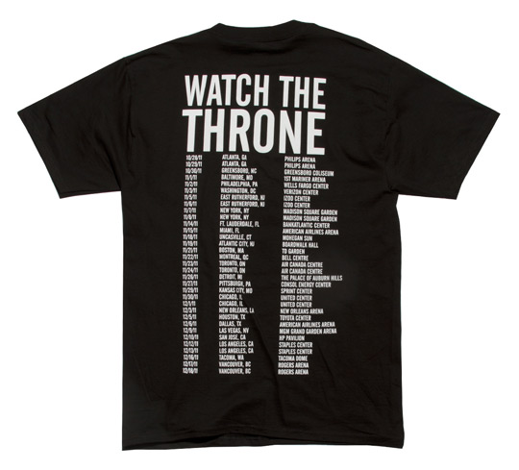
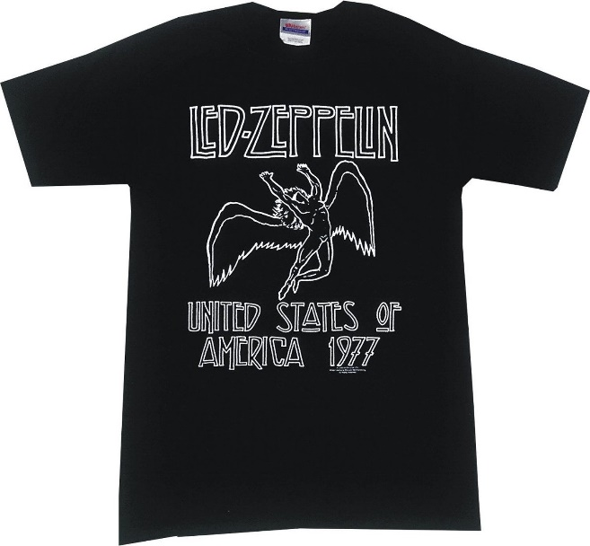
Front: Back:

