Welcome to Pre-AP and AP World History (WHAP)!

This next year will be challenging so here are some summer suggestions to get you ready. Assignments follow.

Electronic Copy:
http://mrnealworldhistory.weebly.com/summer-assignment.html

Dear Pre-AP World History Student:
Welcome to Pre-AP World History! Some of you will have Ms. Kerr, others will have Mr. Neal, but we are both very excited to meet you and explore the history of the world together. Congratulations on your choice to take AP or Pre-AP World History, a challenging course that is designed to prepare you for the Advanced Placement Test this year and beyond.

Although Pre-AP World History and AP World History are separate classes, they will run very similarly. Both classes are designed to teach you the same skills needed in order to successfully conquer AP exam this year! That’s right; some of you enrolled in the Pre-AP level will feel ready enough by the AP exam come May, that even YOU will have the opportunity to test for college credit as a sophomore! Regardless if you decide to test or not, this course will challenge you, and persistent hard work and effort will pay off with great rewards.

To that end, you are expected to complete the following assignment over the summer. Although summer is certainly a time of relaxation and family fun, it is also critical that we get a head start on this course due to the complexity of the task before us and the vastness of the course content, which begins at around 8,000 BCE and ends near the present.

The summer assignment serves two purposes: it is a test of the seriousness of your commitment to doing advanced level coursework in World History and it helps you to gain a critical head start on your studies. The following assignment is MANDATORY, and must be completed before school starts. The attached course work will be graded based on correctness, depth, and quality of answers.

Good Luck and have a great summer,

Anna Kerr/Brett Neal
Your World History teachers!

Course Materials to purchase -

For the Student:
  - Three Ring Binder (2 ” or larger), dividers (8 pack), pens, pencils, highlighters, and notebook paper
  - Optional: World History: Preparing for the Advanced Placement Exam – AMSCO Publishing (2018 edition)
      - Although optional, it is highly recommended as a study source for students seriously considering taking the AP exam. The AMSCO book can be purchased online for $18.95 at this website.
https://www.perfectionlearning.com/social-studies/advanced-placement/world-history-ap-exam.html

For the Classroom:
- If last name begins with A-H = 1 box of Kleenex
- If last name begins with G-Q = 1 box of Markers
- If last name begins with R-Z = 1 box of Colored Pencils

Summer Assignments:
- Complete the Unit 1 Content Search
- Completed World Regions Map
- Complete Unit 1 overview map
- Organized Binder

***ALL ASSIGNMENTS DUE: Friday, August 24th***

If you have any questions please email: Anna.Kerr@springbranchisd.com Brett.Neal@springbranchisd.com

Ms. Kerr and Mr. Neal

Summer Assignment Grading Rubric – Test Grade

Requirements | Points | Your Points
Unit 1 Content Search | 40
World Regions Map | 20
Unit 1 Overview Map | 20
Binder with tabs | 20
Extra Credit – Class Supply (Kleenex, Markers, Colored Pencils) | 10
TOTAL | 110

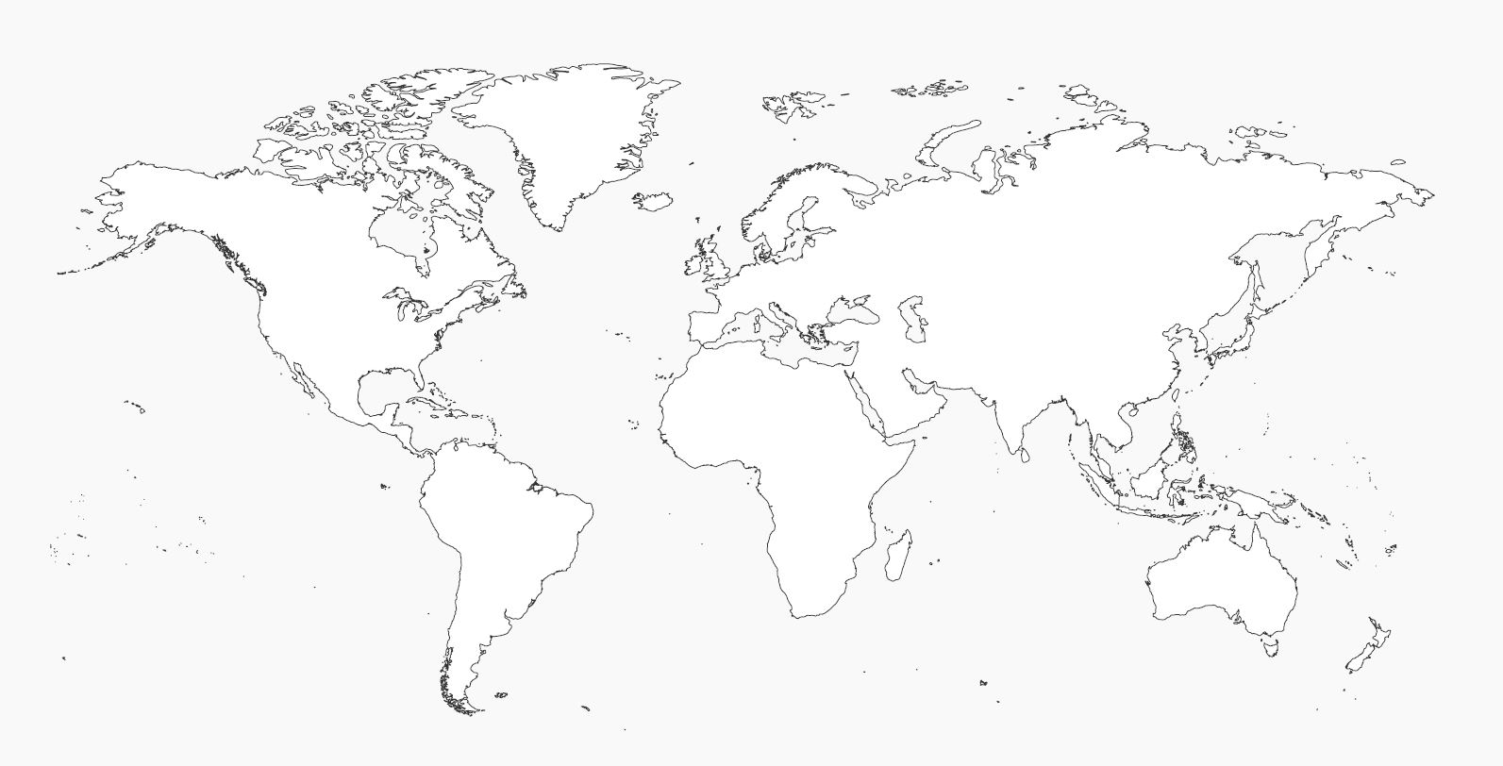

World Regions Map

Use the following website to map the sub-regions used by College Board on the AP Test:
http://moodle.nisdtx.org/mod/resource/view.php?id=519382

Map the following regions. Use a pen to draw your lines and label each region name. Use different colored pencils to shade each of the regions, don’t use the same color for neighboring regions. Use “stripes” to show overlapping regions. (e.i. North America/Mexico)

- North America
- Mexico
- The Caribbean
- Latin America
- Europe
- The Middle East
- Central Asia
- East Asia
- South Asia
- Southeast Asia
- North Africa
- West Africa
- East Africa
- Central Africa
- Southern Africa
- Oceania

Label the following Bodies of Water in pen

- The Atlantic Ocean
- The Pacific Ocean
- The Indian Ocean
- The Mediterranean Sea

Unit 1 Overview Map

Use a pen to label the the following civilizations that existed before 600 BCE. Use different colored pencils (except blue) to show the extent of the civilization. Be sure to use maps that reflect the dates 10,000 BCE - 600 BCE. (ex. don’t map the shape of Egypt from 2018)

- Mesopotamia
- Egypt (Nile River Valley)
- Indus River Valley
- Shang China (Huang He or Yellow River Valley)
- Olmec
- Chavin

Use blue pen a blue colored pencil to draw the following rivers. You DO NOT need to label the river names, simply draw a line showing the shape and extent of the following rivers

- Tigris River
- Euphrates River
- Nile River
- Indus River
- Huang He River (or Yellow River)
- Yangtze River (or Chang Jiang River)

Content Search 1.1

There is a lot of information that we will need to cover in our AP/Pre-AP course. It isn’t possible for us to cover it all in class, you will have to use these content searches as the main way to learn and absorb new historical content. We will then use this knowledge in all of our in-class activities. If you fail to complete these content searches you will fall behind in every aspect of our class. You must thoroughly complete them. This means you should take detailed notes half a page to a page in length (you may use bullet points for notes). The questions below are Socratic Seminar questions that we will use in class. We will have weekly Socratic Seminars and you may be called upon to be a speaker. You need to be prepared. For each question there are a lot of options that you can choose from in order to answer the question. You DO NOT have to view all resources but I would encourage 2 per question. You may pick the ways in which you learn best: reading, watching, or listening. One common resource we will use is the AMSCO book. This is a World History textbook by the publishing company, AMSCO. A PDF verison of the first two chapters can be found below: https://mrnealworldhistory.weebly.com/summer-assignment.html

- Throughout the Paleolithic period, humans migrated from Africa to Eurasia, Australia, and the Americas. Early humans were mobile and creative in adapting to different geographical settings and developed varied and sophisticated technologies. How did humans adapt to the new environments they were inhabiting across the globe?
  - AMSCO p. 2-4
  - Smithsonian Magazine Article: http://www.smithsonianmag.com/science-nature/ability-to-adapt-gave-early-humans-edge-hominin-180951959/

- People lived in small groups. What did the hunter/gatherer societies look like?
  - BBC Earth Video: https://www.youtube.com/watch?v=826HMLoiE_o
  - Article: https://www.ancient.eu/article/991/prehistoric-hunter-gatherer-societies/

- One alternative to agricultural societies was pastoralism. What is pastoralism and how could it negatively impact the environment?
  - A Modern Day Look at Pastoralism: https://www.youtube.com/watch?v=Ws8WXKAThK8
  - Article: https://hubpages.com/education/Pastoral-Societies-Environment
  - Crash Course World History #1: https://www.youtube.com/watch?v=Yocja_N5s1I

- About 10, 000 years ago settled agriculture appeared in several different parts of the world. The switch to agriculture created a more reliable food supply. What are the results of early civilizations?
  - Crash Course World History #1: Agricultural Revolution: https://www.youtube.com/watch?v=Yocja_N5s1I&list=PLBDA2E52FB1EF80C9 (Information from this video may help other answer other questions.)

- One of the first agricultural societies that emerged was Mesopotamia. What were some of the characteristics of early Mesopotamia? What was the purpose behind ziggurats? What was their written language? What was significant about it?
  - AMSCO; pgs. 17-21
  - Crash Course: Mesopotamia (Can be used for all questions related to Mesopotamia.) https://www.youtube.com/watch?v=sohXPx_XZ6Y
  - Khan Academy Video: https://www.youtube.com/watch?v=9GQdh2eGP-Y

- Babylon was a region within Mesopotamia. The Babylonians had a king- Hammurabi. Hammurabi is known for his law code. Describe the characteristics of Hammurabi’s law code.
  - YouTube Video: https://www.youtube.com/watch?v=oDALXORbtR4
  - History.com Article: http://www.history.com/topics/ancient-history/hammurabi

- Mesopotamia is also the birthplace of Judaism. Explain the creation of Judaism.
  - AMSCO; pg. 22-23
  - History.com Video: http://www.history.com/topics/ancient-history/hammurabi/videos/exile-of-the-jews
  - YouTube animation: https://www.youtube.com/watch?v=HyEaAcPGAhA

- The Nile River Valley was an additional early agricultural society. How did the Egyptians utilize the water they had access to in order to grow crops?
  - Crash Course: https://www.youtube.com/watch?v=Z3Wvw6BivVI
  - Youtube: https://www.youtube.com/watch?v=dm8945K4dH0
  - Article: http://www.bbc.co.uk/history/ancient/egyptians/nile_01.shtml

- Ancient Egypt gave us the pyramids and hieroglyphics. What impressed you about these two cultural contributions?
  - AMSCO; pgs. 23-28
  - How was it really built? https://www.youtube.com/watch?v=C1y8N0ePuF8
  - Hieroglyphics: https://www.youtube.com/watch?v=ZBiuJ40t4rk

- What technological innovations could be seen through the civilizations of the Indus River Valley and Shang China?
  - The Indus River Valley city of Harrapa
    - Crash Course: Indus Valley Civilization https://www.youtube.com/watch?v=n7ndRwqJYDM&list=PLBDA2E52FB1EF80C9&index=2
    - AMSCO; pgs. 30-32
  - Shang China (The Huang He Valley)
    - AMSCO; pgs. 33-37

- How did the Shang utilize metallurgy in order to produce Bronze items?
  - YouTube: https://www.youtube.com/watch?v=wj4HFHloZqU

Setting Up Your Class Binder
You are required to have your 2” binder in class daily. All work will go into your binder; it is an organizational tool to help you study for class tests & essays and for the national AP Exam. You will submit your organized binder with your summer assignment placed in the following sections on the summer assignment due date (Friday, August 24th).

Binder Set-Up:
- Cover: First and Last Name and class period (in permanent marker or sharpie)
- Inside - Dividers:
Divider | Title
1 | AP resources
2 | Period 1 (8000 BCE – 600 BCE)
3 | Period 2 (600BCE – 600 CE)
4 | Period 3 (600 CE – 1450 CE)
5 | Period 4 (1450 CE – 1750 CE)
6 | Period 5 (1750 CE – 1900 CE)
7 | Period 6 (1900 CE – Present)

Behind the AP Resources tab, place the following assignment
  - World Regions Map

Behind the Period 1 Divider, place the following assignment in this order
  - Unit 1 Overview Map
  - Content Search 1.1

