Document-Based Question

55 minutes (15 min. reading & 40 min. writing)
Directions: The question is based on the accompanying documents. The documents have been edited for the purpose of this exercise.

In your response you should do the following.
- Thesis: Present a thesis that makes a historically defensible claim and responds to all parts of the question. The thesis must consist of one or more sentences locate in one place, either the introduction or the conclusion.
- Argument Development: Develop and support a cohesive argument that recognizes and accounts for historical complexity by explicitly illustrating relationships among historical evidence such as contradiction, corroboration, and/or qualification.
- Use of the Documents: Utilize the content of at least six of the documents to support the stated thesis or a relevant argument.
- Sourcing the Documents: Explain the significance of the author’s point of view, author’s purpose, historical context, and/or audience for at least four documents.
- Contextualization: Situate the argument by explaining the broader historical events, developments, or processes immediately relevant to the question.
- Outside Evidence: Provide an example or additional piece of specific evidence beyond those found in the documents to support or qualify the argument.
- Synthesis: Extend the argument by explaining the connection between the argument and ONE of the following.
  - A development in a different historical period, situation, era, or geographical area.
  - A course theme and/or approach to history that is not the focus of the essay (such as political, economic, social, cultural, or intellectual history).
  - A different discipline or field of inquiry (such as economics, government and politics, art history, or anthropology).

Question: Using the documents provided and your knowledge of world history, analyze the causes of the Protestant Reformation in the fifteenth and sixteenth centuries.

Document 1
6. The pope cannot remit (cancel) any guilt, except by declaring and showing that it has been remitted by God; or, to be sure, by remitting guilt in cases reserved to his judgment. If his right to grant remissions in these cases were disregarded, the guilt would certainly remain unforgiven.
21. Thus those indulgence preachers are in error who say that a man is absolved from every penalty and saved by papal indulgences.
27. They preach only human doctrines who say that as soon as the money clinks into the money chest, the soul flies out of purgatory.
32. Those who believe that they can be certain of their salvation because they have indulgence letters will be eternally damned, together with their teachers.
43. Christians are to be taught that he who gives to the poor or lends to the needy does a better deed that he who buys indulgences.
Source: The Ninety-Five Theses or Disputations on the Power and Efficacy of Indulgences of 1517 by Martin Luther. Reprinted with permission in, Reformation Reader, 2nd ed. Ed. Denis R. Janz. Minneapolis: Fortress Press. 2008.

Document 2
“I cannot submit my faith either to the Pope or to the Councils, because it is clear as day they have frequently erred and contradicted eachother. Unless, therefore, I am convinced by the testimony of the Scripture…I cannot and will not retract…Here I stand, I can do no other. So help me my God, Amen.”
Source: Martin Luther’s reply when summoned to appear before the Emperor at the Diet (Assembly) of Worms to answer for writing his 95 Theses.

Document 3
“Those who are the closest to theologians in happiness are generally called ‘the religious’ or ‘monks,’ both of which are deceiving names, since for the most part they stay as far away from religion as possible and frequent every sort of place… Though most people detest these men so much that accidentally meeting one is considered to be bad luck, the monks themselves believe that they are magnificent creatures.”
Source: Erasmus of Rotterdam, “The Praise of Folly,” 1511

Document 4
As Rome prepared the heavy artillery, Luther fired off more salvos (shots), with the help of the press. His sermons, tracts and polemics (written attacks), all in German…streamed from presses by the hundreds of thousands…. According to one estimate, a third of all books printed in Germany between 1518 and 1525 were by him. Pause to consider that figure. Of course, printing was in its infancy, but Germany at the time was turning out about a million books a year, of which a third-300,000- were by Luther. No comparison with the modern world stands up, but it would be the equivalent of one author selling almost 300 million books in Britain (which prints some 800 million a year), or 700 million in the US, every year, for seven years running.
Source: John Man, Gutenberg: How One Man Remade the World with Words, 2002.

Document 5
“Arise, O Lord, and judge Thy cause. A wild boar has invaded Thy vineyard…Arise all ye saints, and the whole universal Church, whose interpretations of Scripture has been assailed (attacked).”
Source: Papal Bull (letter) of Pope Leo X, 1520.

Document 6
Paul testifies that the Church is built on the foundation of the apostles and prophets, (Eph. 2:20). If the doctrine of the apostles and prophets is the foundation of the Church, the former must have had its certainty before the latter began to exist…For if the Christian Church was founded at first on the writings of the apostles, that doctrine, wheresoever it may be found, was certainly ascertained and sanctioned antecedently to the Church, since, but for this, the Church herself never could have existed. Nothing therefore can be more absurd that the fiction, that the power of judging Scripture is in the Church, and that on her nod is certainty depends.
Source: Institutes of the Christian Religion; Book 1, Chapter 7, Section 2 (1559), John Calvin

Document 7
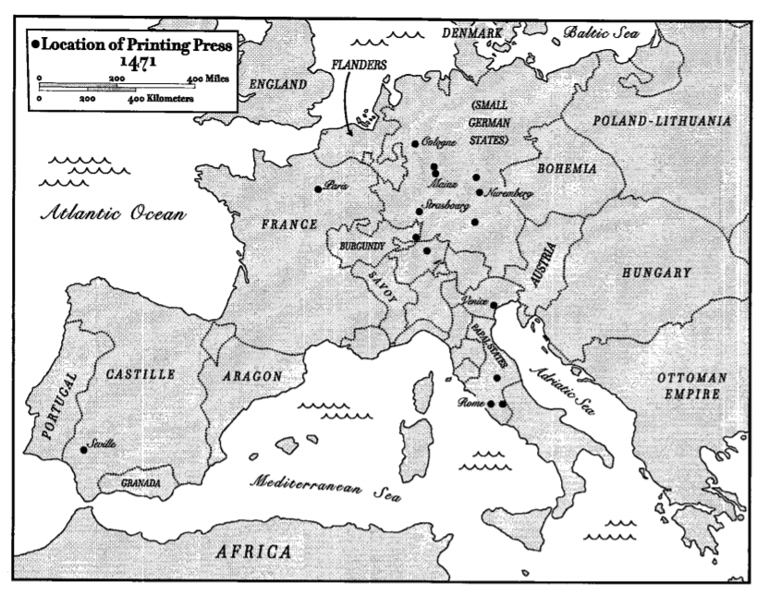
Source: The Spread of Printing. Maps created from various sources.

