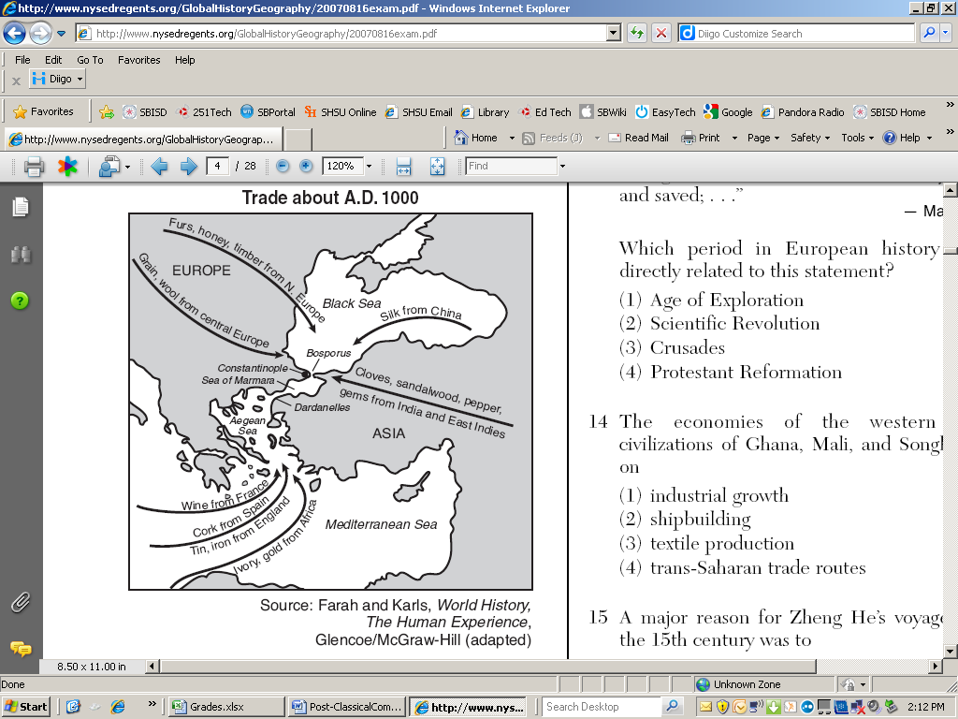

1. Based on the information provided by this map, which statement about Constantinople is accurate?
   1. Africans traded more goods in Constantinople than in any other area.
   2. Constantinople was an important trading center due to its geographical location.
   3. Constantinople did not receive items from East Asia
   4. Merchants in Constantinople were mostly interested in precious metals
2. Which of the following was true of American societies during the time period 600-1450?
   1. Communication and exchange networks developed
   2. Civilizations grew independently and remained isolated to even those in close proximity
   3. Agricultural techniques used were similar to those of Western Europe
   4. Little was known of math, medicine, and astronomy
3. The growth of interregional trade in luxury items between the years 600-1450 CE can be mostly attributed to which of the following factors
   1. Cheaper prices due to newly discovered silver deposits in the Americas
   2. Innovations in navigation and commercial instruments such as the astrolabe, compass, and paper money
   3. New found interest in tourism due to the recordings of famous world travelers like Marco Polo and Zheng He
   4. Decreased exposure to epidemic diseases led to a natural increase in population

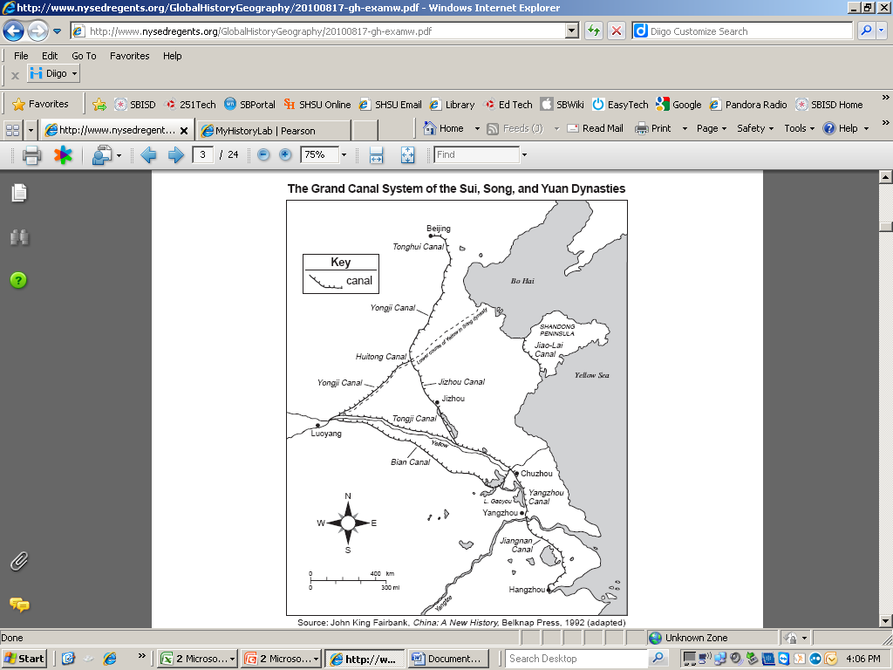

1. Which conclusion about the Grand Canal system in China can be drawn from the information shown on the map?
2. Coastal ports dominated the canal system.
3. Troops could easily be moved west of Luoyang on the canals.
4. Grain could be shipped between Hangzhou and Beijing by the canal.
5. The canal system prevented invaders from conquering the dynasties.
6. What was the effect of the extensive Mongol Empire on the people who lived in Europe and Asia in the 1200s?
   1. development of a common language
   2. adoption of Confucian ideas and practices
   3. significant increases in trade and travel
   4. expansion of Japanese cultural traditions
7. Which of the following made long distant trade possible, especially across areas with harsh conditions?
   1. Donkeys
   2. Camels
   3. Salt
   4. Slaves
8. Which of the following was an environmental impact of migrating people groups such as the Bantu speaking peoples or the Polynesians during the period 600-1450?
   1. The destruction of natural habitats due to soil erosion and pollution
   2. The endangerment of certain animal species due to over hunting
   3. The introduction of new diseases to each population encountered
   4. The cultivation of transplanted foods and domesticated animals as they moved to new areas
9. Which of the following was an example of cultural diffusion closely associated with the Bantu migrations in Sub Saharan Africa?
   1. The spread of language
   2. The spread of religion
   3. The spread of disease
   4. The spread of animal handling
10. After its birth as a new religion, Islam mostly expanded to parts of Afro-Eurasia due to which of the following?
    1. Mass production of the Quran in Arabic
    2. Merchants, missionaries, and military expansion
    3. Early support and conversions from women and peasants
    4. Religious tolerance in long established empires
11. In the period 600 C.E. to 1450 C.E., merchant diaspora communities, such as those of Muslims in India, Chinese in Southeast Asia, and Jews in the Mediterranean, had which of the following in common?
    1. They generally introduced their own cultural practices into the local cultures.
    2. They generally imposed their own languages on the local communities.
    3. They generally became military outposts that facilitated the expansion of empires
    4. They generally lost touch with their homelands and merged with the local population
12. One important consequence of journal entries from travelers, such as Marco Polo and Ibn Battuta was__
    1. The development of slavery
    2. A reduction of trade
    3. The discovery of East Africa
    4. An increased interest in different cultures



1. This photograph of a mosque (first erected in the 14th century) in the modern-day West African country of Mali best exemplifies which of the following historical processes?
   1. Imposition of religion through military conquest
   2. spread of religion along trade routes
   3. abandonment of indigenous cultural styles in the face of colonization
   4. conflict between local and universalizing religions
2. Which of the following best explains the changes illustrated in the chart during the mid-fourteenth century?
   1. The introduction of the bubonic plague to Europe
   2. An increase in peasant revolts during the Hundred Years’ War
   3. The environmental effects of climate change
   4. The Mongol invasions
3. Which of the following was an important long-term demographic impact of the spread of new rice varieties in East Asia during the period circa 600 C.E. to 1200 C.E.?
4. A decrease in the size of East Asian cities outside the rice-growing area
5. The large-scale settlement of nomadic central Asians into farming communities
6. A rapid increase of East Asian populations
7. The movement of large numbers of East Asians from cities to farms
8. Which of the following describes a similarity in the methods of political control used by the Sui and Song Dynasties of China during the Post-Classical era?
   1. Both implemented versions of Confucianism to reinforce patriarchy
   2. Both promoted foreign religions through government sponsored construction of worship centers
   3. Both sought to advance women socially through creation of formal legal codes
   4. Both reinforced laws through previously established court systems

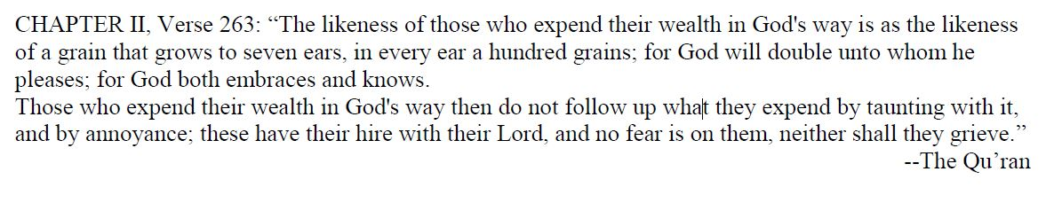

1. The passage above depicts which main tenet of the faith described in the passage?
2. Pilgrimage to Mecca
3. Prayer
4. Fasting
5. Almsgiving
6. Which of the following largely describes the reason why feudalism began in western Europe
   1. Turmoil from repeated invasions from Germanic tribes
   2. The Muslim capturing of the city of Jerusalem
   3. City of Constantinople falling to the Ottoman Turks
   4. Mongol invasions from the East
7. Which statement about cultural diffusion in Asia is most accurate?
8. Byzantine traders brought political policies such as the Justinian Code to China.
9. Roman legions introduced Christianity to the Indian subcontinent.
10. Indian monks brought Islam to the Middle East.
11. Chinese ideas and practices spread into Japan and were synthesized with local traditions.
12. Which of the following was true of political systems in the Americas by the end of the 15th century?
    1. Civilizations were at constant war with one another and never peacefully exchanged goods or ideas
    2. Some civilizations expanded from a collection of city states to great empires
    3. Epidemics such as smallpox had nearly wiped out all long established civilizations
    4. City states in Latin American remained isolated from one another
13. What was the impact of the Crusades on the Christian West?
    1. Christians rejected most Muslim influence, although they did gain a taste for Muslim wines and liquors.
    2. Christians adopted military techniques, words, scientific learning, and Arabic numerals among other things.
    3. There was no Muslim influence on the Christian West.
    4. The Crusades interrupted the trade of the Mediterranean and cut off the West from Islam until 1293.
14. Which of the following was true of agriculture in the Americas prior to the arrival of Europeans in the late 1400’s?
    1. Native populations were innovative in their techniques such as terrace farming and *chinampas* to adapt to their unique environments
    2. Agricultural techniques used were no different than that of Afro-Eurasian farmers
    3. Farming was done on a small scale due to the abundance of animal populations
    4. Agriculture was limited due to the difficult terrain in which many native populations settled
15. Which of the following was a direct consequence of increased demand for luxury items in Eurasia from 1000-1300 CE?
    1. East Asian cities became widely overpopulated as they became home to diasporic merchant communities
    2. Ports along the Mediterranean Sea began to close due to surmounting interest in East Asian products
    3. Political tension amongst neighboring nations due to economic competition
    4. Merchants and guild artisans expanded their production of desired products such as porcelain and textiles

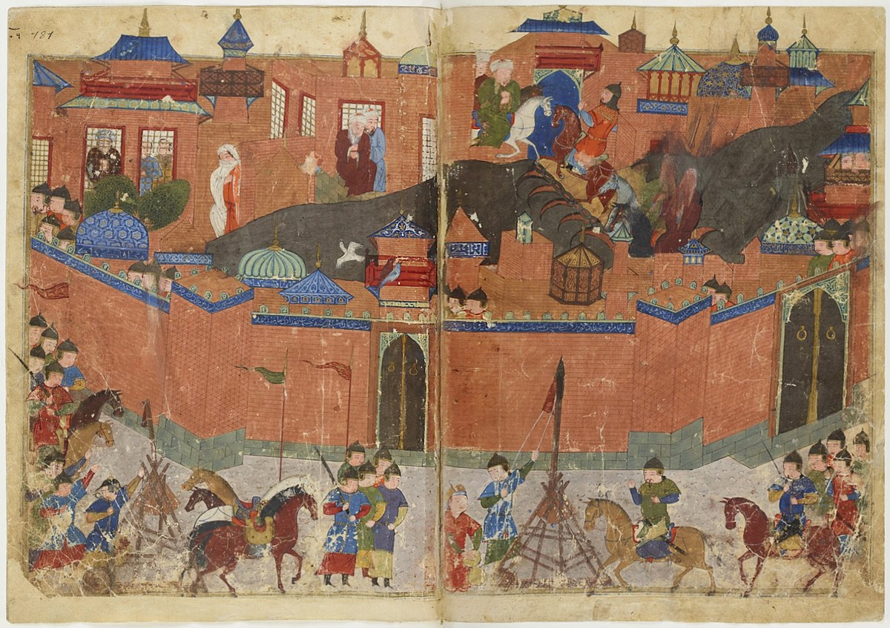

*Source: Depiction of the Mongol siege of Baghdad in 1258*

1. Using the image above, which of the following inferences can be made about the Mongols?
   1. Mongols would often destroy cities and their populations during their conquest of Asia
   2. The Mongols had much trouble in their conquest of walled cities
   3. Urban populations and their dwellings were typically spared by the Mongols
   4. Mongol military was typically disorganized and lacked technology necessary for siege warfare
2. The Mongol conquests of much of Eurasia in the thirteenth century tended to encourage urban development and trade along the Silk Roads primarily by
3. opening large new markets for both European and East Asian goods in Central Asia
4. increasing the demand for military supplies needed by the Mongol armies that occupied various regions
5. decreasing the risk of bandit attacks and reducing the number of local rulers collecting tribute from trade caravans
6. discouraging seaborne trade along the Indian Ocean routes that competed with the Silk Roads

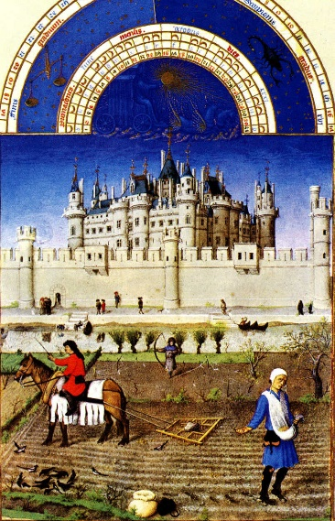

Source: “Labor of the Months”

1. The above image from the early 1400s show scenes of the daily lives of the lower classes on a “manor” in Europe. Which of the following inferences can be held true based on the artist’s depiction?
   1. Peasants could not be given land claims based upon their position in feudal societies
   2. The majority of serfs worked as skilled craftsmen rather than farmers
   3. Feudal societies were largely dependent on serfdom and free peasant labor
   4. Elite classes in feudal society had little to no dependence on peasant labor

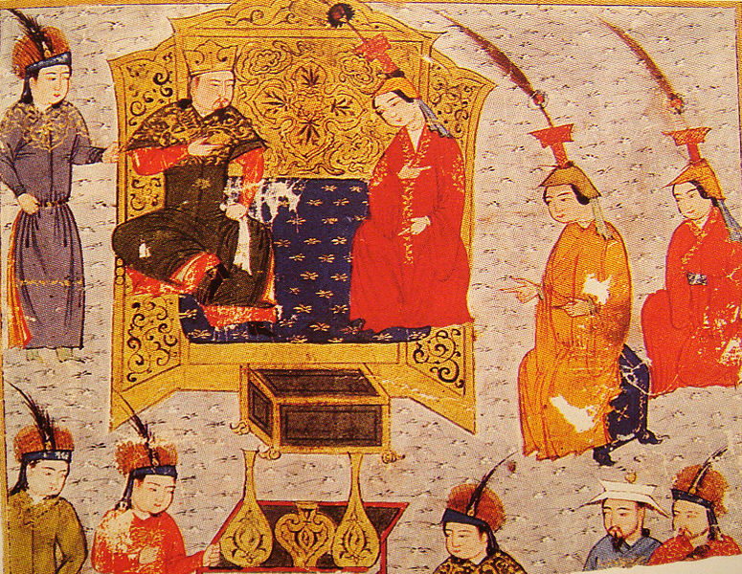

Source: A drawing of Hugalu Khan, ruler of the Ilkhanate, seated with his wife

1. What assumption can be made about Mongol society by analyzing the image above?
   1. Mongol women enjoyed less freedoms compared to those of Chinese women during the same time period
   2. Women were could become highly valued participants in Mongol society
   3. Men enjoyed less freedoms compared to those of Mongol Women
   4. Mongol rulers often disregarded women and their opinions on state affairs.

*“The evil-disposed in these districts [of England] began to rise, saying, they were too severely oppressed; that at the beginning of the world there were no slaves, and that no one ought to be treated as such. . . . This they would not longer bear, but had determined to be free, and if they labored for their lords, they wanted to be paid for it. A crazy priest in the county of Kent, called John Ball, who for his absurd preaching, had been thrice confined in prison, inflamed those ideas. He would say: ‘Are we not all descended from the same parents, Adam and Eve? and what can the lords show, or what reasons give, why they should be more the masters than ourselves?’ ”*

*Jean Froissart, account of a peasant revolt in England, 1381*

1. The description of the peasant revolt in the passage above best supports which of the following conclusions?
2. Peasants were hostile to the idea of wage labor.
3. Peasants used religious beliefs to justify their resistance.
4. Peasant demands for equality were supported by the highest levels of religious leaders.
5. Peasant revolts were more frequent in England than elsewhere in this period.
6. In what way did foot-binding serve to diminish the independence of Chinese women by the end of the Song era?
7. Foot-binding, although considered socially attractive, was condemned by neo-Confucians.
8. Because foot-binding could only be afforded by the elite, poorer women were assigned to a lower social status.
9. Foot-binding sufficiently crippled women to effectively confine their mobility to their household.
10. Upper-class women considered it high status and hoarded money to pay for it.

**AP Style questions**

*Use the following excerpt to answer questions 29-31*

“On our arrival we entered the large court, where the great Montezuma was awaiting our Captain. Taking him by the hand, the prince led him to his apartment in the hall where he was to lodge, which was very richly furnished in their manner. Montezuma had ready for him a very rich necklace, made of golden crabs, a marvelous piece of work, which he hung round Cortes’ neck. His captains were greatly astonished at this sign of honor.

I must now speak of the skilled workmen whom Montezuma employed in all the crafts they practiced, beginning with the jewelers and workers in silver and gold and various kinds of hollowed objects, which excited the admiration of our great silversmiths at home. Many of the best of them lived in a town called Atzcapotzalco, three miles from Mexico. There were other skilled craftsmen who worked with precious stones…and specialists in feather-work, and very fine painters and carvers. We can form some judgment of what they did then from what we can see of their work today.”

*Source: Bernal Diaz - Spanish conquistador, 1519.*

1. The tone of the passage is most consistent with which of the following statements?
2. State-building in the Americas created less developed governments than those in Afro-Eurasia
3. European visitors approached the Americas with greed and economic motives
4. The Aztecs were a mostly violent people, prone to war and conquest
5. Governing bodies in the Americas enjoyed wealth on par with those of Afro-Eurasia

1. What does the passage suggest about the Aztec economy?
2. Interaction between the Aztecs and neighboring peoples resulted in the diffusion of artistic and economic items
3. Aztec farms produced enough for survival of local lords and serfs
4. Aztec merchants connected the societies of Andean South America with North America
5. Aztec merchants were the highest-regarded members of their society
6. What was a primary cause of the growth of the city described in the passage?
7. Migration to the Aztec Empire from the Inca Empire
8. Population growth due to new strains of agricultural products arriving in the Aztec Empire
9. Population growth due to the use of the *chinampa* agricultural technique
10. Population growth due to terrace farming of local mountains

*Use the source below to answer questions 32-33*

PLAN OF THE TANG DYNASTY CAPITAL CITY OF CHANG’AN, EIGHTH CENTURY C.E.

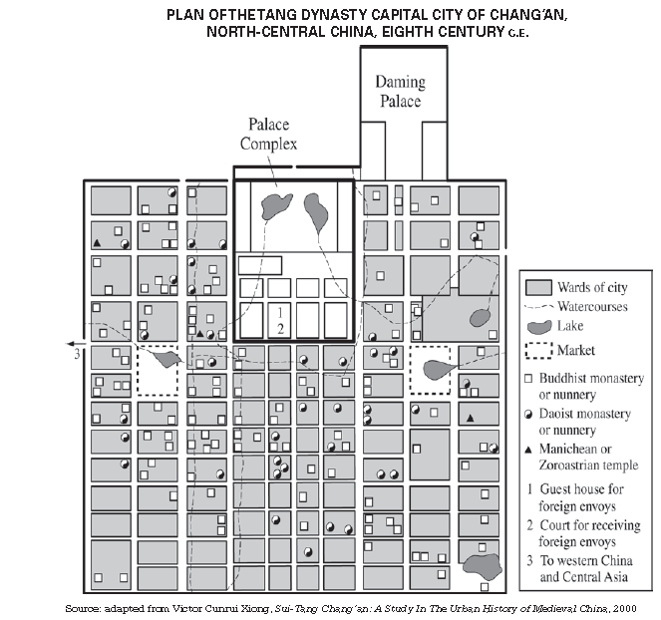

1. The layout of the city as shown in the map most clearly reflects which of the following developments of the time period?
2. Societies using technological adaptations to deal with changing environments
3. Populations increasing as a result of new crops such as Champa rice
4. Cities and towns implementing new measures to control the spread of epidemic disease
5. Governments building infrastructure to promote economic activity
6. The variety of temples shown on the map of Chang’an was most likely the result of which of the following broader processes from 600 to 1450 C.E.?
7. Diffusion of cultural traditions along the Silk Roads
8. Conquests by nomadic Central Asian groups
9. Religious conflict resulting from the An Lushan rebellion
10. Neo-Confucian influence on the Tang government

*Use the source below to answer questions 34-36*

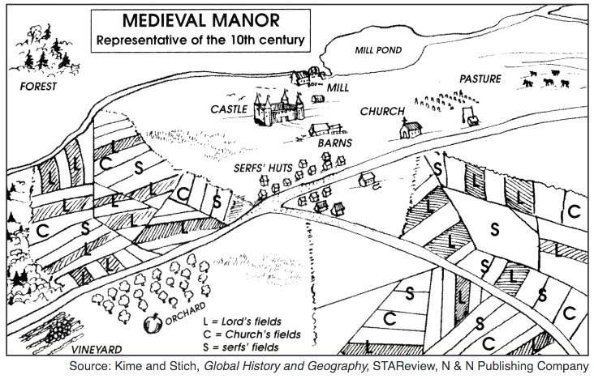

1. The dominant form of labor organization shown in this example of a Medieval Manor was
   1. Peasant agriculture
   2. Nomadic Pastoralism
   3. Coerced Slave Labor
   4. City based Craft and Guilds
2. The agricultural productivity shown above caused an increase in population in rural areas of Western Europe, which of the following environmental developments in East Asia led to a population growth during the period between 600 C.E. to 1450 C.E.?
   1. The introduction of Banana trees from Africa
   2. The cultivation of Champa Rice in China
   3. Spread of crops such as cotton, sugar, and citrus fruits between Eurasian regions.
   4. The diffusion and spread of the disease pathogens such as the Bubonic Plague.
3. Which of the following would have caused the serfs on this manor to revolt during the time period shown on this diagram?
   1. Invasions by foreign enemies such as the Scandinavian Vikings.
   2. Intensified contacts with the Middle East as a result of the Crusades.
   3. Coercive taxation and tributes demanded by the state on agricultural production.
   4. The diffusion and spread of the disease pathogens such as the Bubonic Plague.

*Use the source below to answer questions 37-39*

**The following map displays the spread of paper making technologies which began in Central China and then spread throughout Afro-Eurasia. Dates are displayed in C.E. unless otherwise noted.**

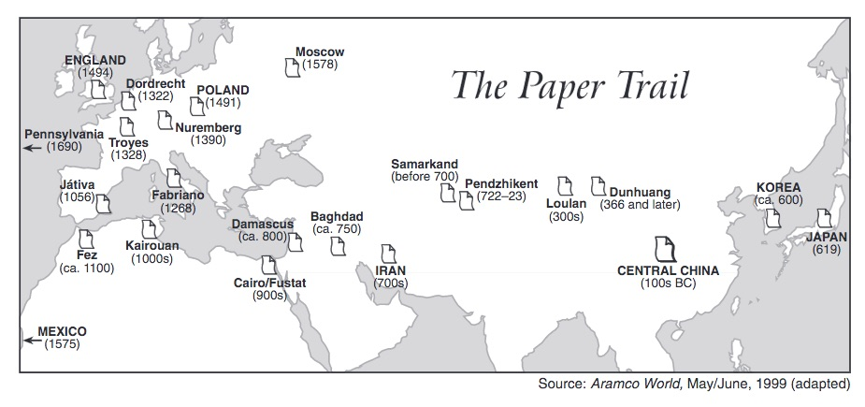

1. Which of the following trade routes would have been MOST used to spread the technology depicted on the map across Central Asia into the rest of Afro-Eurasia?
   1. The Silk Roads
   2. The Mediterranean Sea Routes
   3. The Trans-Saharan Sand Routes
   4. The Indian Ocean Sea Routes
2. Which of the following economic innovations of the period between 600 to 1450 C.E. would have been a direct result of this technology?
   1. Tributary and tax systems
   2. Use of the number 0 in accounting
   3. Coercive labor systems
   4. Printed paper currency
3. Which is the best possible political explanation for the facilitation of papermaking technologies into the Middle East and North Africa during the dates provided?
   1. The increased desire Christian literature after the legalization of the religion in Western Europe
   2. The expansion of Islamic Caliphates brought new technologies to conquered areas
   3. Chinese government sponsored voyages of Zheng He
   4. Mongol occupation of the Asian continent

*Use the source below to answer questions 40-42*

Source: Francesco Balducci Pegolotti on the journey from Italy to China,

*Merchant’s Handbook*, c.1340s CE

On the road you will find plenty of [Mongols]. You should furnish yourself with a dragoman [translator]. And besides the dragoman it will be well to take at least two good men servants, who are acquainted with the [Mongol] tongue. The road you travel to [China] is perfectly safe, whether by day or by night, according to what the merchants say who have used it. [China] is a province which contained a multitude of cities and towns. Among others there is one in particular, that is to say the capital city, to which is great resort of merchants, and in which there is a vast amount of trade.

1. Which of the following primary sources would properly contradict Pegolotti’s description of the Mongols he encountered?
   1. A drawing of Mongol women sitting alongside her husband
   2. A journal entry from Marco Polo about his encounters with Kublai Khan
   3. A Persian manuscript describing attacks on Muslim urban centers in the Middle East
   4. A painting of a Mongol nomadic tribe deconstructing their Yurts, or Gers
2. Which of the following was an immediate result of the published works of travelers such as the source above?
   1. An increase in travel and trade due to newfound interest in foreign lands
   2. A decrease in long distance trade due to well documented theft along the silk roads
   3. The beginning of trans-oceanic travel to find uncharted lands
   4. A rise in literacy rates throughout Afro-Eurasia as a result of newly desired reading materials
3. Which of the following was true of most thriving urban centers such as the one described in the passage?
   1. Foreign merchants did not usually stay very long before having to journey home
   2. Religious tolerance was uncommon in East Asia
   3. It was difficult to find a place to stay if you did not know anyone inhabiting the city
   4. Diasporic communities of foreign merchants were typical of these economic centers

*Use the source below to answer questions 43-45*

Yuan Cai (c. 1140-1195), The Problems of Women, Chinese official and scholar

Women do not take part in extramarital affairs. The reason that worthy husbands and sons take care of everything for them, while unworthy ones can always find ways to hide their deeds from the women.

Many men today indulge in pleasure and gambling; some end up mortgaging their lands, and even go so far as to mortgage their houses without their wives’ knowledge. Therefore, when husbands are bad, even if wives try to handle outside matters, it is of no use. Sons must have their mothers’ signatures to mortgage their family properties, but there are sons who falsify papers and forge signatures, sometimes borrowing money at high interest from people who would not hesitate to bring their claim to court.

Therefore, when sons are bad, it is useless for the mothers to try and handle matters relating to the outside world.

1. The author’s view of the relationship between a wife and husband as well as between a mother and her son are most clearly affected by
   1. The introduction of ideas from Islam as a result of reestablishment of Silk Road trade.
   2. The resurgence of Confucianism
   3. The establishment of Legalism as the dominant Chinese philosophy.
   4. A reaction against the influence of Buddhism in China and the freedoms granted to women converts.
2. The patriarchal trend shown above directly correlates with which of the following 10th century political changes in China
   1. The beginning of the Song dynasty
   2. Moving the capital city from Chang’an to Dongjing
   3. The government led construction of Buddhist temples during the reign of Empress Wu
   4. The establishment of a court system during the Tang dynasty

1. Which of the following best explains the difference between the roles of women in China as seen in the passage to those of surrounding Asian cultures during this same time period.
2. Chinese women experienced more freedoms than that of Mongol women
3. Women of Japan had fewer liberties than that of Chinese women
4. Patriarchy continued throughout Asia, but some cultures granted women more freedoms than the Chinese
5. Women would take on roles as political leaders everywhere else besides China

**Questions 46-48 refer to the passage below.**

“Let the following be abolished: the titles held by imperial princes to serfs granted by imperialdecrees *(koshiro),* the title to lands held directly by the imperial court *(miyake);* and private titles to lands and workers help by ministers and functionaries of the course, by local nobles, and by village chiefs. In lieu thereof, sustenance household* shall be granted to those of the rank of *Daibu* (chief of a bureau or ward) and upwards on a scale corresponding to their positions.... It is said that the duty of the Daibu is to govern the people. If they discharge their task diligently, the people will have trust in them. Therefore, it is for the benefit of the people that the revenue of the *Daibu* shall be increased.”

*--Edict of Taika, Japan, 645 CE*

\**sustenance household* – designated households whose taxes paid salaries of officials

1. The system being abolished in this passage is most closely similar to which of the following
   1. The Confuscian style government reinstated by the Sui
   2. The religiously tolerant Tang Dynasty
   3. The Neo-Confuscian government established by the Song
   4. The feudal societies of Western Europe
2. The bureaucratic system replacing the old ways of governance within Japan was most likely borrowed from which neighboring society
   1. The Polynesians
   2. The Mongols
   3. The Arabs
   4. The Chinese
3. One effect of the collapse of the system above in Japan after the year 1000 was
   1. a return to a more centralized system based on powerful nobles working under an emperor
   2. a more decentralized system and the establishment of a feudal structure under a shogun
   3. the creation of a military-state with a new emphasis on expansionist policies
   4. the creation of a tributary state after a period of invasion by outside forces

**Questions 49-51 refer to the two sources below.**

Source 1

“Suju is a very great and noble city. The people are Idolaters, subjects of the Great Khan, and have paper money. They possess silk in great quantities, from which they make gold brocade and other stuffs, and they live by their manufactures and trade. The city is passing great, and has a circuit of some 60 miles; it hath merchants of great wealth and an incalculable number of people. Indeed, if the men of this city and of the rest of Manzi had but the spirit of soldiers they would conquer the world; but they are no soldiers at all, only accomplished traders and most skillful craftsmen. There are also in this city many great philosophers and leeches, diligent students of nature.”

--Marco Polo, *The Book of Ser Marco Polo: The Venetian Concerning Kingdoms and Marvels of the East, Volumes I and II*, translated and edited by Colonel Sir Henry Yule, 1903

Source 2

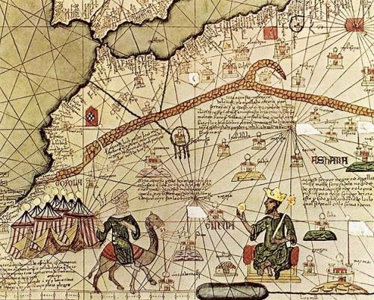

*Catalan Atlas, fourteenth-century Italian Map of West Africa showing the travels of King Mansa Musa*

1. Which of the following empires is most credited for the facilitation of trade in the city described in source 1?
2. Song
3. Byzantine
4. Umayyad Caliphate
5. Mongols
6. Which of the following Post-Classical developments would help travelers in source 2 more so than Marco Polo?
   1. Astrolabe
   2. Caravanserai
   3. Camels
   4. Junks

**Questions 53-55 refer to the two sources below.**

Source 1

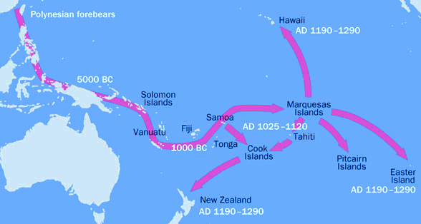

Source 2

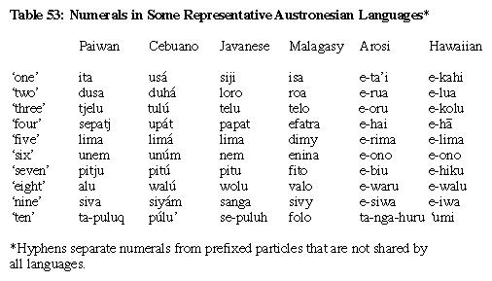

**Numerals in Some Representative Polynesian languages**

1. Which of the following environmental effects occurred as a result of the Polynesian migrations shown above?
   1. The extinction of certain animals due to over hunting
   2. The spread of epidemic diseases to populations encountered along their pathway
   3. The transplanting of foods and animals from surrounding areas
   4. The alteration of the natural geography through the construction of man-made canals
2. Which of the following describes a cultural similarity shared between the Polynesians migrations and the Bantu migrations in Sub Saharan Africa?
   1. The spread of linguistic patterns
   2. The spread of iron working techniques
   3. The spread of epidemic diseases
   4. The spread of religious traditions

**Questions 53-55 refer to the two sources below.**

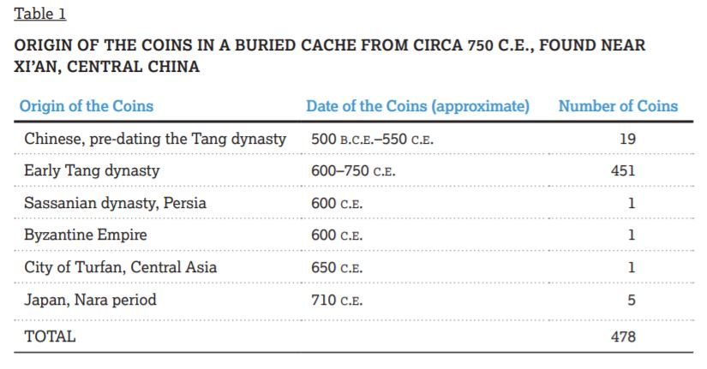

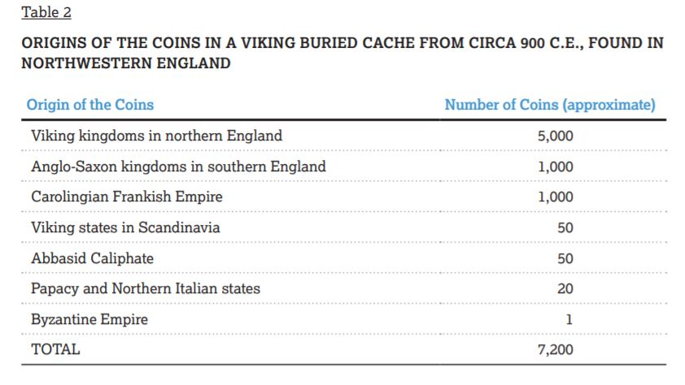

1. Which of the following conclusions is best supported by the data shown in source 1?
   1. Long-distance trade routes were active during the early Tang period, even as most trade in China remained local
   2. The majority of economic transactions in Tang China continued to be carried out through bartering
   3. The Tang Emperor’s legitimacy continued to be challenged in many parts of China
   4. Long distance trade resulted in the creation of new cities and the establishment of diasporic merchant communities
2. A historian researching the economic history of Eurasia in the period circa 600 CE – 1450 CE would most likely find the two tables useful as a source of information about which of the following?
   1. The diffusion of cultural traditions along Eurasian trade routes
   2. The spread of technological innovations across regions of Eurasia
   3. The geographic extent of the monetization of Eurasian economics
   4. The extent to which government economic policies in the Post-Classical era represented a continuity of earlier time periods
3. Which of the following advancements particularly helped in the Viking economic endeavors rather than the Chinese?
   1. The compass
   2. The astrolabe
   3. Paper Money
   4. The long ship